Mechanical Concepts
Student Name
School Name
Instructor:
11/08/2018
Background
Kinetics (forces and moments) is majorly concerned with the causes of motion. The moment of force is the force that makes the body to rotate. In the recent world, biomechanics has been used in a number of occasions in order to enhance method a number of ways in which athletes try to do their activities differently. Their instructors on the other hand have made use of kinetics in order to ensure that the athletes can remain competitive in their races through the execution of a well-planned championship. Kinetics in enable the athletes to make it is big challenges such as playing tennis in world championships or jumping huddles. In the main case, instructors of the champions make use of subjective biomechanical skills and strategies in their regular educating and training to impact changes in the manner in which they compete. Biomechanics scientist utilizes quantitative biomechanical skills and strategies to find new procedures, which at that point must be conveyed to the instructors and mentors who will execute them [1].
In order to make motions as a gym instructor, coach, athlete, acrobat there is need of forces and moments that effectively lead to
- Tuck more tightly,
- Bounce higher than usual,
- Swing arms more vivaciously.
These proposals may all outcome in enhanced execution and depend on biomechanical standards. Hopping higher will obviously give the athlete additional time that is needed in order to finish the somersault. Tucking more tightly will make the gymnast to rotate speedier because of preservation of rakish force. Swinging the arms more vivaciously before taking off will create more momentum, in this way likewise making the acrobat rotate a little bit speedier. All in all, this is the most widely recognized rather circumstance in which biomechanics affects the result of any applied skill. Mentors and instructors utilize biomechanics to figure out what activities may enhance good execution of the exercise or activity [2].
The second situation whereby biomechanics adds to enhanced execution through kinetics happens when biomechanics scientists develop different successful procedures which are important for athletes and they are able to use in exercising. In spite of the basic conviction that new and progressive procedures are frequently created by biomechanists, such improvements are uncommon. It is usually regarded that biomechanics as a discipline can be defined as a new science. The significantly more typical result of biomechanics research is the disclosure of little refinements in system. One case of biomechanics is a situation whereby it influences the procedure as well as exhibitions in a game took place in swimming in the ‘60s up to the70s. That lifting or pulling the hand it propelled through the water is critical in moving a an athlete or a swimmer in the water in propulsive drag force [3]
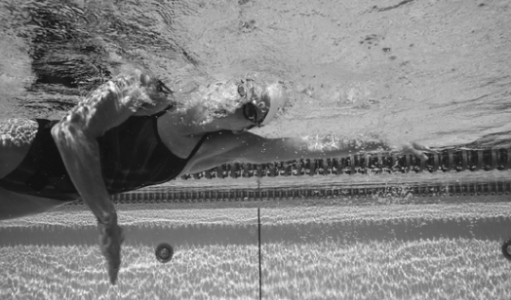
This exploration showed that as opposed to pulling the turn in a straight line in reverse through the water to create a propulsive drag compel, the swimmer should, however, move the hand forward and backward in a broad activity as it is pulled in reverse to deliver propulsive lift powers and as well more propulsive drag powers. This method is presently educated by swimming educators and mentors all through the world.
Different cases of games in which sensational changes in method delivered emotional change in execution incorporate spear tossing, high bouncing, and cross-country skiing. In 1956, preceding the Summer Olympic Games in Melbourne one of the participants, Felix, resigned plate hurler from the Basque area of Spain, explored different avenues regarding an unpredictable method for tossing the lance. In this situation, Felix had involvement in barra vasca, a conventional Basque sport that included tossing an iron bar known as the palanka. In order to toss the iron bar, it was necessary to make a turn and Felix fused this turn in his creative lance tossing method. As opposed to tossing in a traditional method which commonly involved throwing over the shoulder with one hand after a short run. In this case, Felix held the lance with his correct hand simply behind the hold and threw it far beyond the expected target. The tip of the lance pointed right down his right hand, while the tail of the iron bar faced the back and pointed upward. At first before the throw, Felix spun around like a disk hurler and threw the lance from his correct hand, which guided the overall launch. In order to diminish the frictional powers following up on the spear as it slid through his hand, it had been dunked in sudsy water to make it elusive. The exceptional outcomes accomplished by Felix and other athletes with this method pulled in worldwide consideration. A few hurlers utilizing this "progressive" system recorded tosses that were in excess of 10 m past the current lance world record [4]
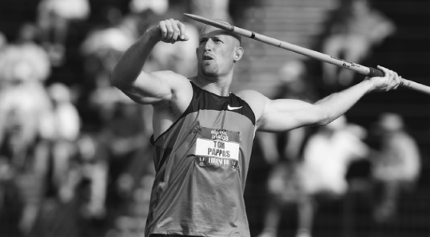
Mechanical concepts
Using mechanical concepts of kinetics to study human movement with utility in athletic performance e.g. athletic training, work out and participation in different exercises is one of the major developments in engineering today. A moment of force can be described as a measure of the force’s tendency, which makes the body to rotate. A good example is whereby a champion who is on a horizontal bar rotates when he/she produces a moment of force as per the bar. The factors, which contribute to external force acting on the free body, include;
- Central force
The central force is the external force whereby its vector line passes via the center of gravity of the body of the gymnast. However, this central force only causes the linear motion and acts directly on the bobsleigh in the track’s straight line.
- Pair of forces
The pair of forces can be defined as the identical magnitude forces, which occur in opposite direction but not exactly on the same line. The pair of forces results to rotary motion and the result is zero thus not changing the linear motion.
- Eccentric force
It is an external force whose factor line don’t pass via the COG of the athlete’s body. This force results to changes to both linear as well as rotary motion. A good example is where a force that enables the gymnast to take off in a squat vault over the challenge [5]
Research journal papers
The moment of force magnitude is the force, which acts upon a point, and it is usually directly proportional to the magnitude of the force as well as the distance of the point to the vector line, which produces the moment. The moment arm is the distance between the selected point and the vector line of the force [6].
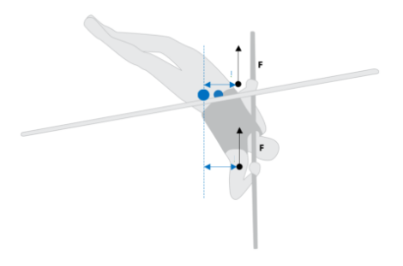
In this case, the Blue dot lies at the center of gravity of the champion. Blue arrows indicate the moment arms relative to the center of rotation as well as the COG. The black arrows indicate the reaction forces on which the pole acts on the athlete’s arms.
In order to analyze and describe the moment of force, it is important to first realize the point of application of the force, direction, and the magnitude. When the vector of the force can be traced on the plane, which is perpendicular to the axis of rotation of the body. In this case, it is better to choose the moment point of intersection of the axis of rotation and the point of intersection of the plane [4].
The body of humans is not rigid and can constantly change its shape through the movement of the arms, head. In this manner, individuals can control their body solidness by changing the position of their body. For instance, how do athletes begin a race when strolling? First, they lean forward until the middle of their bodies reach past the forefoot. At that point many people who fail to master the position lose stability and begin to fall once again. The other leg breaks the fall and the entire procedure is rehashed. In this manner, we can depict strolling as a progression of controlled falls, arrivals, and departures. In numerous games, competitors endeavor to augment their security for the most part or just one particular way. In a few games, we attempt in specific circumstances to expand portability (and limit strength) [4].
On the off chance that the power that is endeavoring to bother us has a specific heading, we should make utilization of changing the base of our situation to accomplish stability that is more prominent. For instance when playing forward stroke, most of the tennis players attempt to put their feet far separated toward the oncoming ball and in this way to expand their front-to-back adjustment. In order to gain more stability, they also stand in either of the sideways of the incoming ball while one foot is toward the stroke their feet. Both feet are usually not next to each other. Boxers and ball players utilize comparable procedure. The situation with one foot in front is extremely great in many donning circumstances. It permits to decrease or increment energy and effect drive in given time, yet it likewise gives greater strength.
.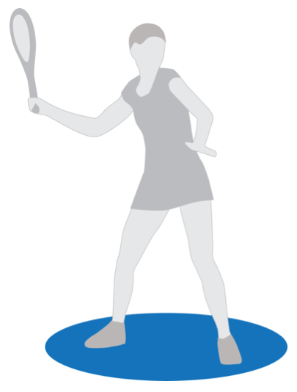
In specific circumstances, many athletes raise their stability by utilizing different equipment. Individuals with leg wounds regularly utilize braces to expand their dependability. Skiers raise their body’s stability through the front to back bearing with the assistance of skis. The more drawn out the skis, the better the front to back stability. That is the reason in skiing one has to utilize longer skis than slalom racers. Both need better front to back strength. They regularly utilize short skis to work on funcarving. Short skis enable educators to identify whether understudies have redress fundamental downhill skiing position. In the event that an understudy begins to fall forward or in reverse amid preparing with short skis, it is an indication of inaccurate fundamental skiing position in the feeling of front to back body stability [7].
Sprinters toward the beginning of an endeavor try to have a position that would enable them to advance as quick as could be expected under the circumstances. The sprinter's focal point of gravity is before the toe of any of the front foot, which is the center at which the body will pivot amid the initial step. Immediately the flag is waved to start the race, the sprinter rises his arms and instantly begins going forward. He/she is halted by the power of his/her legs in order to stabilize once again and move forward using the power gained. Swimmers likewise begin from a place of least dependability. Tennis champions in particular times of a stroke use an exceptional position in order to enlarge quality toward the stroke. In specific circumstances, individuals increment their steadiness by utilizing hardware. Individuals with leg wounds regularly utilize supports to build their steadiness. Skiers increment their strength in front to back course with the assistance of skis themselves. The more drawn out the skis, the better the front to back soundness. That is the reason downhillers utilize longer skis than slalom racers. They require better front to back solidness [8]. We regularly utilize short skis to work on fun carving. Short skis enable teachers to recognize whether understudies have redress essential downhill skiing position. On the off chance that an understudy begins to fall forward or in reverse amid preparing with short skis, it is an indication of inaccurate fundamental skiing position in the feeling of front to back security [2].
Kinetics, is helpful in depicting movement, discloses to us nothing about the powers, which made that development. To analyze the powers following up on the body, the sub teach of energy is utilized. Energy includes taking a gander at all powers, including outside opposition, gravity, and muscle powers utilizing the laws of mechanics found by Sir Isaac Newton in the 1600s. The powers following up on the body are separated into two classes. The first is outside powers. Outer powers are those powers that emerge outside the body. Gravity is one case of an outside power, being the power applied by the earth on the body. Different cases incorporate breeze opposition and the utilization of outside weights to make an obstruction. Interior powers are powers, which emerge from inside the body [9].
Inner powers incorporate muscle powers, the powers applied by tendons, and bone-on-bone powers inside the body. With a specific end goal to make a development, inside powers must be produced in the correct adds up to beat the outer powers following up on the body. Each power has four characteristics:
1) Size, or amount of power,
2) Bearing,
3) Purpose of use of the power, and
4) A line of activity demonstrating where the power is going.
The power quickens the fragment (appendage); altering either the speed or course of the portion, along the line of activity of the power as per Newton's second law of movement:
F=ma

Where F is the power connected, m is the mass of the fragment, and an is the subsequent quickening.
On the off chance that the power does not act straightforwardly on a joint it is called a whimsical, or off kilter, compel. A capricious power, notwithstanding quickening the body or appendage it is following up on, will likewise make the body or appendage pivot about its hub [4]. The turning power is known as a snapshot of power, in some cases alluded to as a torque. The snapshot of power, or essentially the occasion, about every hub has two properties:
1) Extent, and
2) Heading, positive or negative.
By tradition, a minute, which causes a clockwise movement, is called negative, while counterclockwise minute is called positive. The greatness existing apart from everything else is dictated by the condition:

M=Fd

Where M is the greatness of the torque, F is the power connected, and d is known as the minute arm.
The minute arm is equivalent to the most limited separation from the pivot (joint) to the power following up on the appendage, dictated by the line of activity of the power. The minute arm is computed utilizing the condition: d=r where r is the separation from the hub (marked 0) to the point of use of the power and q is the edge between the portion and the power. Just in uncommon cases does just a single power, and in this way just a single minute follow up on a section. A regular case happens when the power of the biceps, the heaviness of the lower arm and hand, and the heaviness of a dumbbell, alluded to as F(Resistance), are following up on the lower arm and hand. At the point when in excess of one power is following up on an appendage, the minutes are included to decide the aggregate minute following up on the appendage [9]. The minute condition of this framework is:

M= Fmdm – Wdw – Fede
The speeding up of the portion relies upon the snapshot of the framework. The portion is quickened toward the path (positive or negative) existing apart from everything else of the framework. So if the minute is sure, the portion is quickened a counterclockwise way. The greatness of the speeding up is given by:
M=Ia
where an is the precise speeding up of the section and I is the snapshot of inactivity, which speaks to the weight circulation of the portion

Summary
The depiction of the solid constriction depends on the movement of the section. In the event that the portion isn't moving and the muscle is getting, the constriction is called an isometric compression. On the off chance that the framework is with the end goal that the fragment is moving toward the muscle compel, the muscle is said to experience a concentric compression. In the event that the circumstance is switched, and the fragment is moving far from the heading of the muscle compel, the muscle is said to experience an erratic withdrawal, regularly called the negative by weight lifters. The minute arm of the biceps muscle is little when contrasted with the minute arms of the other two powers. This is the circumstance, which typically happens in the body. An examination existing apart from everything else arms of the powers is made when mechanical productivity is ascertained. The mechanical favorable position of a framework is:

Mechanical Advantage=IA/EA
Where IA is the minute arm of the inside powers and EA is the minute arm of the outside powers.

Since the minute arms of the muscles in the body has a tendency to be littler than the minute arms of the outside powers, the mechanical preferred standpoint is generally under 1. The little mechanical preferred standpoint implies that expansive powers must be connected to conquer the outside powers. Regardless of this hindrance, the little mechanical favorable position is yet accommodating since it has the property of permitting a huge scope of movement for little measures of muscle shortening.
The Fitness Professional Perspective
While a portion of the above data does not appear to be straightforwardly appropriate to the advancement of a standard workout schedule, the standards displayed involve the basic premise of all developments performed in game, exercise, and day-by-day exercises. It is the comprehension of these ideas, which, to a limited extent, enable the wellness expert to adequately apply inquire about in program, plans to support advance, limit damage, and additionally convey consequences of such usage suitably [10].

References

[1] | Knudson, D. (2013). Fundamentals of Biomechanics. Boston, MA: Springer
[2] | McGinnis, P. M. (2013). Biomechanics of sport and exercise. Champaign, IL: Human Kinetics.
[3] | Schoenfeld, B. (2016). Science and development of muscle hypertrophy.
[4] | Maud, P. J., & Foster, C. (2016). Physiological assessment of human fitness. Leeds: Human Kinetics.
[5] | Brandt, E. N., Pope, A. M. P., & Institute of Medicine (U.S.). (2017). Enabling America: Assessing the role of rehabilitation science and engineering. Washington, D.C: National Academy Press.
[6] | Dutton, M. (2011). Orthopaedics for the physical therapist assistant.
[7] | Whyman, W. (2018). Outdoor site and facility management: Tools for creating memorable places. Champaign, IL: Human Kinetics.
[8] | Loudon, J. K., Swift, M., & Bell, S. (2015). The clinical orthopedic assessment guide. Champaign, IL: Human Kinetics.
[9] | Alter, M. J. (2014). Science of flexibility. Champaign, IL: Human Kinetics.
[10] | Abu-Faraj, Z. O. (2012). Handbook of research on biomedical engineering education and advanced bioengineering learning: Interdisciplinary concepts.
[11] | D. (. Knudson.

